Components of the project :

Name |  | Image | Quantity | Price of one piece | Reference | Total
Flame detector sensor |  | 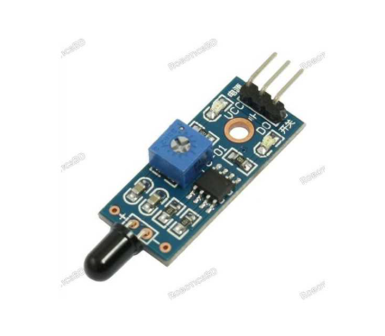 | 4 | 75 | https://store.roboticsbd.com/sensors/149-flame-sensor-fire-detection-module-robotics-bangladesh.html | 300
Buzzer |  | 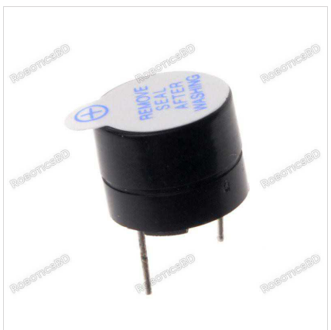 | 1 | 20 | https://store.roboticsbd.com/components/753-active-buzzer-5v-robotics-bangladesh.html | 20
IC(or gate) 4 pin  4072 |  | 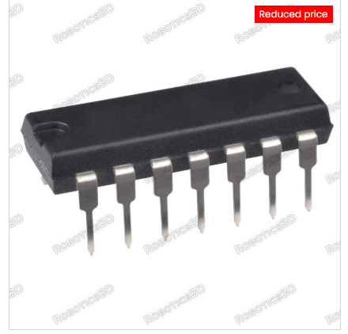 | 1 | 35 | https://store.roboticsbd.com/digital-ics/1986-ic-4072-4-input-or-gate-robotics-bangladesh.html | 35
IC(Decoder) 4 to 16  74HC154 |  | 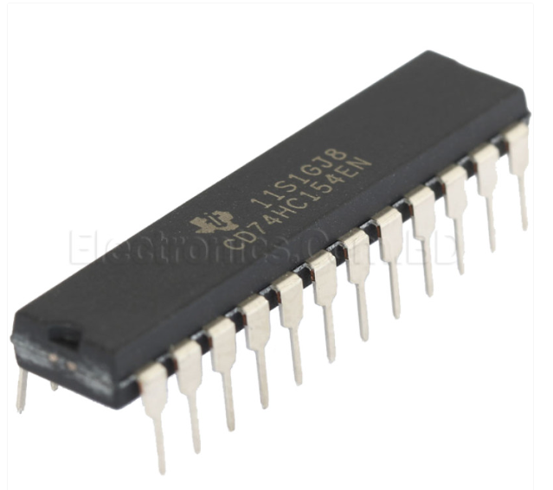 | 1 | 185 | https://www.electronics.com.bd/74ls154-74154-74hc154-decoder-parts-ic-module-sensor-arduino-transistor-resistor-capacitor-robotics-project-electronics-bangladesh?route=product/product&srsltid=AfmBOooAmAt8iVLxWWKd5_p0KThAD1Dr-zBF8LR2-g2rtRgD4KffPPHG | 185
Breadboard |  | 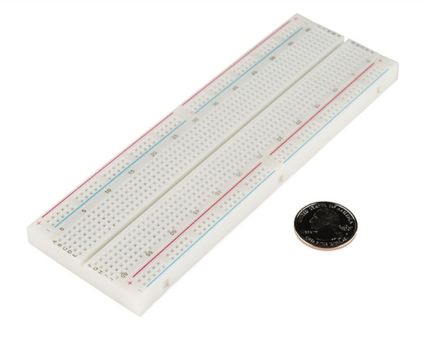 | 1 | 150 - 200 | https://store.roboticsbd.com/breadboard-prototype/1886-gl-12-breadboard-full-size-bare-830-tie-points-robotics-bangladesh.html | 150-200
IC (not gate )  7404 |  | 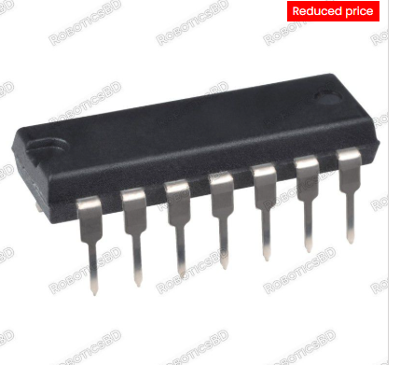 | 3 | 30 | https://store.roboticsbd.com/analog-ics-/1033-7404-pdip14-robotics-bangladesh.html | 90
Red light |  | 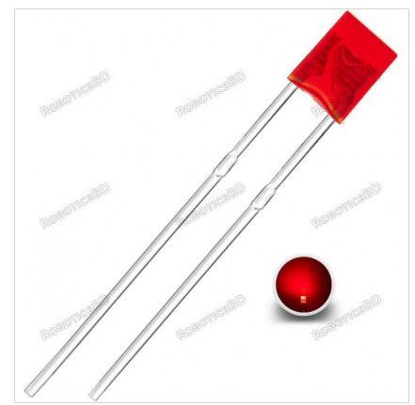 | 1 | 10 | https://store.roboticsbd.com/led/2501-red-led-rectangular-2x5x7mm-robotics-bangladesh.html | 10
Wires : | Single core wire ( 26AWG or 24 AWG) | 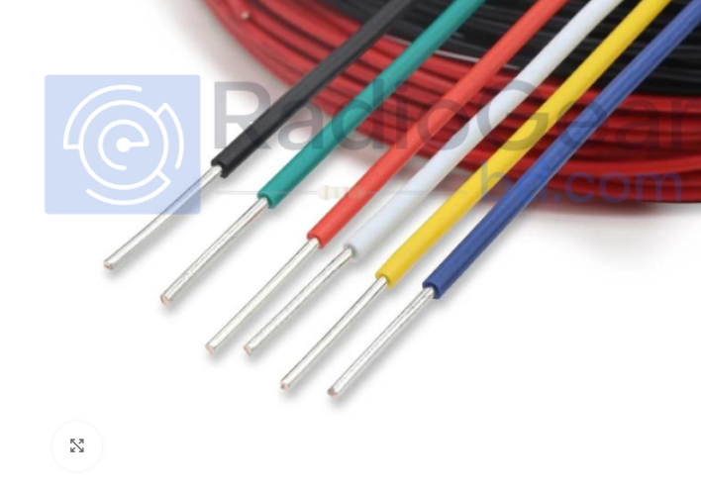 | Will decide later | 50-100 |  | 50-100
Wires : | Female to male | 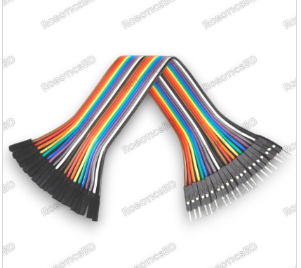 | 20 piece pack | 55 |  | 55
Total |  |  |  |  |  | 895

